**ASSIGNMENT 1 FRONT SHEET**

|  |  |  |  |
| --- | --- | --- | --- |
| **Qualification** | **BTEC Level 5 HND Diploma in Computing** | | |
| **Unit number and title** | Unit 16: Cloud computing | | |
| **Submission date** | 20/06/2021 | **Date Received 1st submission** |  |
| **Re-submission Date** |  | **Date Received 2nd submission** |  |
| **Student Name** | PHAM CAO NGUYEN | **Student ID** | GCC18074 |
| **Class** | GCC0801 | **Assessor name** | THAI MINH TUAN |
| **Student declaration**  I certify that the assignment submission is entirely my own work and I fully understand the consequences of plagiarism. I understand that making a false declaration is a form of malpractice. | | | |
|  |  | **Student’s signature** | CAONGUYEN |

**Grading grid**

|  |  |  |  |  |  |  |
| --- | --- | --- | --- | --- | --- | --- |
| P1 | P2 | P3 | P4 | M1 | M2 | D1 |
|  |  |  |  |  |  |  |

|  |  |  |
| --- | --- | --- |
| **❒ Summative Feedback: ❒ Resubmission Feedback:** | | |
| **Grade:** | **Assessor Signature:** | **Date:** |
| **Internal Verifier’s Comments:** | | |
| **Signature & Date:** | | |

**ASSIGNMENT 1 BRIEF**

|  |  |  |  |
| --- | --- | --- | --- |
| **Qualification** | **BTEC Level 5 HND Diploma in Computing** | | |
| **Unit number** | Unit 16: Cloud computing | | |
| **Assignment title** | Cloud Computing Solutions | | |
| **Academic Year** | 2021 – 2022 | | |
| **Unit Tutor** | DO Quoc Binh | | |
| **Issue date** |  | **Submission date** |  |
| **IV name and date** |  | | |

|  |
| --- |
| **Submission Format:** |
| *Format:* The submission is in the form of 1 document  You must use font *Calibri size 12, set number of the pages and use multiple line spacing at 1.3. Margins must be: left: 1.25 cm; right: 1 cm; top: 1 cm and bottom: 1 cm.* The reference follows Harvard referencing system.  *Submission* Students are compulsory to submit the assignment in due date and in a way requested by the Tutors. The form of submission will be a soft copy posted on <http://cms.greenwich.edu.vn/>  *Note:* The Assignment *must* be your own work, and not copied by or from another student or from  books etc. If you use ideas, quotes or data (such as diagrams) from books, journals or other sources, you must reference your sources, using the Harvard style. Make sure that you know how to reference properly, and that understand the guidelines on plagiarism. *If you do not, you definitely get failed* |
| **Unit Learning Outcomes:** |
| **LO1** Demonstrate an understanding of the fundamentals of Cloud Computing and its architectures.  **LO2** Evaluate the deployment models, service models and technological drivers of Cloud Computing and validate their use. |
| **Assignment Brief and Guidance:** |
| Scenario  ATN is a Vietnamese company which is selling toys to teenagers in many provinces all over Vietnam. The company has the revenue over 700.000 dollars/year. Currently each shop has its own database to store transactions for that shop only. Each shop has to send the sale data to the board director monthly and the board director need lots of time to summarize the data collected from all the shops. Besides the board can’t see the stock information update in real time.  The table of contents in your technical report should be as follows:   1. As a developer, explain to the board director the fundamentals of cloud computing and how it is popular nowadays(about 2500 words) 2. Proposed solution (higher level solution description – around 700 words) and explain the appropriateness of the solution for the scenario (about 400 words with images and diagrams)which might include:    1. Architectural design (architectural diagram and description).    2. Detailed design:       1. Deployment model (discussion on why that model was chosen).       2. Service model (discussion on why that model was chosen).       3. Programming language/ webserver/database server chosen. 3. Summary.   General guidelines:   * Instead of providing definitions but also provide with examples. * Provide more own arguments instead of definitions * Making use of academic references instead of web tutorials * For a cloud architecture look at the bottom of this document |

|  |  |  |
| --- | --- | --- |
| Learning Outcomes and Assessment Criteria | | |
| Pass | Merit | Distinction |
| **LO1** Demonstrate an understanding of the fundamentals of Cloud Computing and its architectures | | **LO1 & 2**  **D1** Justify the tools chosen to realise a Cloud Computing solution. |
| **P1** Analyse the evolution and fundamental concepts of Cloud Computing.  **P2** Design an appropriate architectural Cloud Computing framework for a given scenario. | **M1** Discuss why an organisation should migrate to a Cloud Computing solution. |
| **LO2** Evaluate the deployment models, service models and technological drivers of Cloud Computing and validate their use | |
| **P3** Define an appropriate deployment model for a given scenario.  **P4** Compare the service models for choosing an adequate model for a given scenario. | **M2** Demonstrate these deployment models with real world examples. |

A cloud architecture example:

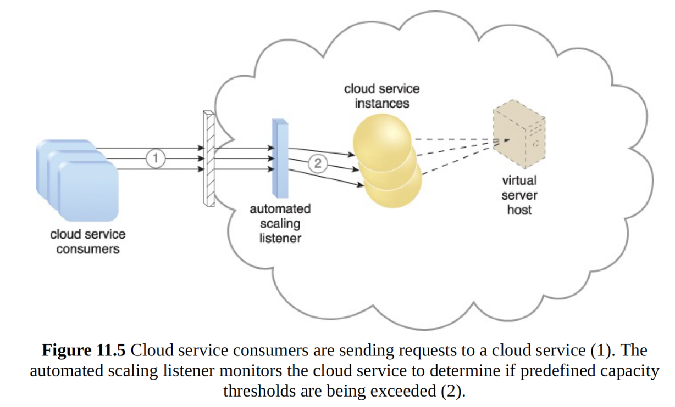

The dynamic scalability architecture can be applied to a range of IT resources, including

virtual servers and cloud storage devices. Besides the core automated scaling listener and

resource replication mechanisms, the following mechanisms can also be used in this form

of cloud architecture:

• Cloud Usage Monitor – Specialized cloud usage monitors can track runtime usage

in response to dynamic fluctuations caused by this architecture.

• Hypervisor – The hypervisor is invoked by a dynamic scalability system to create or

remove virtual server instances, or to be scaled itself.

• Pay-Per-Use Monitor – The pay-per-use monitor is engaged to collect usage cost

information in response to the scaling of IT resources.

Contents

**Analyse the evolution and fundamental concepts of Cloud Computing.** 9

o **Introduction** 9

**1.** **What is Cloud Computing?** 9

**2.** **How does the cloud work?** 10

**3.** **The popularity of Cloud Computer** 10

**4.** **The client-server model** 10

**5.** **Peer-to-peer (P2P)** 13

**6.** **Parallel** 13

**7.** **cluster** 14

**8.** **distributed** 14

**9.** **Example HPC** 14

**10.** **Benefits of cloud computing** 15

**11.** **Advantages of Cloud Computing** 15

**12.** **Disadvantages of Cloud Computing** 16

**13.** **The development of cloud computing today:** 18

**14.** **There are several reasons why the cloud becomes the new popular IT trend:** 18

**15.** **Cloud ecosystem:** 18

**16.** **SaaS: Software as a Service** 19

**17.** **PaaS: Platform as a Service** 20

**18.** **IaaS: Infrastructure as a Service** 21

**19.** **Characteristic of the cloud:** 24

**20.** **Virtualization in cloud computing** 24

**21.** **Multicore in cloud computing** 25

**22.** **Persuade the ATN from adopting cloud computing.** 26

**Design an appropriate architectural Cloud Computing framework for a given scenario.** 26

**Use Case Diagram** 27

**Site map** 28

**Define an appropriate deployment model for a given scenario.** 29

**1.** **Cloud Computing Model** 29

**2.** **Deployment Model** 29

**3.** **Public clouds** 29

**4.** **Private cloud** 30

**5.** **Community cloud** 31

**6.** **Hybrid clouds** 32

**7.** **The comparative analysis of the best deployment models** 32

**Compare the service models for choosing an adequate model for a given scenario.** 32

**8.** **Service model should be used** 32

**9.** **Programming language NodeJS should be used** 33

**10.** **The database should be used is MongoDB** 35

**11.** **Cloud platform should be used is Heroku** 37

**6.** **GitHub** 41

**7.** **Explain the diagram** 42

**Conclusion** 43

**References** 44

# **Analyse the evolution and fundamental concepts of Cloud Computing.**

* **Introduction**

Cloud computing is a model for providing centralized, accessible on-demand network access to a shared pool of configurable computing resources (e.g. networks, devices, data, applications, and services) that can be efficiently dispersed and applied with minimal maintenance intervention or participation of service providers. The cloud infrastructure comprises 5 core components, 3 implementation models, and 4 distribution models.

Computing, also known as Virtual Database Computing, is a technological paradigm centered on information technology and Internet expansion. The term "cloud" is used as a metaphor for both the Internet (as depicted in a computer network diagram) and the complexity of the infrastructures contained within it.

Cloud storage is an integral approach to delivering IT as software. It is an Internet-based networking system that offers common services such as the delivery of power over the grid. The cloud machines are designed to operate together, and the combined processing capacity is utilized by different programs, as though they were operating on one machine. Flexibility in cloud infrastructure is a feature of the on-demand distribution of services. It makes the usage of accrued device capital simpler and negates the need to delegate unique equipment to a mission. Web pages and server-based applications had been executed on a particular system prior to cloud computing. The introduction of cloud storage allows the use of tools like a virtual computer. This single architecture offers an atmosphere where programs are operating separately, unaware of any individual architecture.

* + - 1. **What is Cloud Computing?**

Cloud computing is a term referred to storing and accessing data over the internet. It doesn’t store any data on the hard disk of your personal computer. In cloud computing, you can access data from a remote server. (Furht, 2010)

Cloud computing is the delivery of different services through the Internet. These resources include tools and applications like data storage, servers, databases, networking, and software.

Rather than keeping files on a proprietary hard drive or local storage device, cloud-based storage makes it possible to save them to a remote database. As long as an electronic device has access to the web, it has access to the data and the software programs to run it.

Cloud computing is a popular option for people and businesses for a number of reasons including cost savings, increased productivity, speed and efficiency, performance, and security.

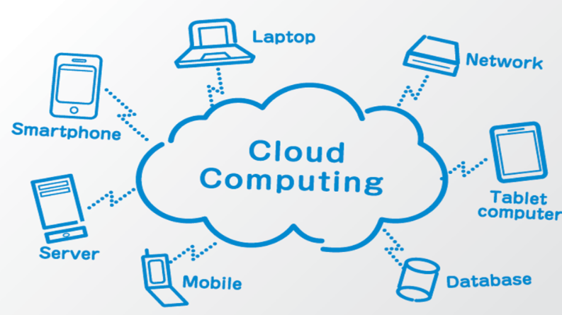

**Example:**

Cloud computing underpins a vast number of services. That includes consumer services like Gmail or the cloud backup of the photos on your smartphone, though to the services which allow large enterprises to host all their data and run all of their applications in the cloud. Netflix relies on cloud computing services to run its video streaming service and its other business systems too and has a number of other organizations.

* + - 1. **How does the cloud work?**

Cloud computing allows users to access services such as servers, data, and the Internet. It operates, controls, and retains a network link through the cloud service provider. In the meanwhile, the online site should support consumers and use what they want. (Furht, 2010)

* + - 1. **The popularity of Cloud Computer**

Amazon Web Services (AWS), Google Cloud Platform, Microsoft Aruze, Google Apps, Android Apps, iCloud, App Store, MS Store… are all deployed on the Cloud Computing platform.

Currently, it is only the early period, because the capacity is too ceaseless to operate in new fields such as IoT (Internet of Things - Internet of Things) or AI (Artificial Intelligence)

1. **The client-server model**

The client-server model is a distributed application structure that partitions tasks or workloads between the providers of a resource or service, called servers, and service requesters called clients. Often clients and servers communicate over a computer network on separate hardware, but both client and server may reside in the same system. A server host runs one or more server programs that share their resources with clients. A client does not share any of its resources but requests a server’s content or service function. Clients, therefore, initiate communication sessions with servers that await incoming requests. Examples of computer applications that use the client-server model are Email, network printing, and the World Wide Web. (Furht, 2010)

Cloud computing is a model for enabling ubiquitous, convenient, on-demand network access to a shared pool of configurable computing resources (e.g., networks, servers, storage, applications, and services) that can be rapidly provisioned and released with minimal management effort or service provider interaction.

On-demand self-service. A consumer can unilaterally provision computing capabilities, such as server time and network storage, as needed automatically without requiring human interaction with each service provider.

Broad network access. Capabilities are available over the network and accessed through standard mechanisms that promote use by heterogeneous thin or thick client platforms (e.g., mobile phones, tablets, laptops, and workstations).

Resource pooling. The provider’s computing resources are pooled to serve multiple consumers using a multi-tenant model, with different physical and virtual resources dynamically assigned and reassigned according to consumer demand. There is a sense of location independence in that the customer generally has no control or knowledge over the exact location of the provided resources but may be able to specify location at a higher level of abstraction (e.g., country, state, or datacenter). Examples of resources include storage, processing, memory, and network bandwidth.

Rapid elasticity. Capabilities can be elastically provisioned and released, in some cases automatically, to scale rapidly outward and inward commensurate with demand. To the consumer, the capabilities available for provisioning often appear to be unlimited and can be appropriated in any quantity at any time.

Measured service. Cloud systems automatically control and optimize resource use by leveraging a metering capability1 at some level of abstraction appropriate to the type of service (e.g., storage, processing, bandwidth, and active user accounts). Resource usage can be monitored, controlled, and reported, providing transparency for both the provider and consumer of the utilized service.

**Fat client**

A fat client is a networked computer with many locally-stored programs or resources and little dependence on network resources, such as auxiliary drives, CD-RW/DVD players or software applications. Typically, users prefer fat client computers over thin clients because fat clients allow easy customization and greater control over installed programs and system configuration. (Furht, 2010)

Because output is locally generated, a fat client also enables a more sophisticated graphical user interface (GUI) and reduced server load.

**Thin client**

A thin client is a computer that runs from resources stored on a central server instead of a localized hard drive. Thin clients work by connecting remotely to a server-based computing environment where most applications, sensitive data, and memory, are stored. (Furht, 2010)

**Concurrent and iterative servers**

An iterative server handles both the connection request and the transaction involved in the call itself. Iterative servers are fairly simple and are suitable for transactions that do not last long.

However, if the transaction takes more time, queues can build up quickly. In Figure below “An iterative server”, once Client A starts a transaction with the server, Client B cannot make a call until A has finished.

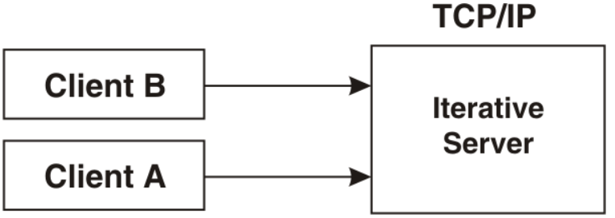

So, for lengthy transactions, a different sort of server is needed — the concurrent server, as shown in Figure below “A concurrent server”. Here, Client A has already established a connection with the server, which has then created a child server process to handle the transaction. This allows the server to process Client B’s request without waiting for A’s transaction to complete. More than one child server can be started in this way.

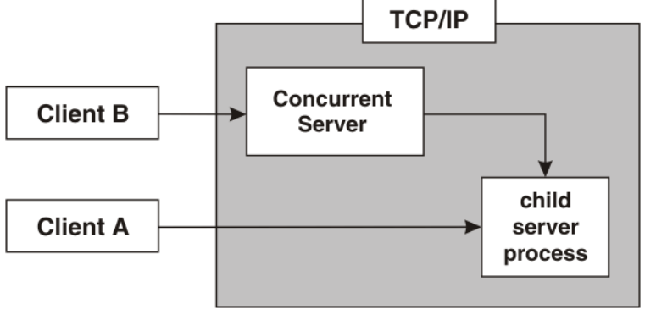

1. **Peer-to-peer (P2P)**

Peer-to-peer (P2P) computing or networking is a distributed application architecture that partitions tasks or workloads between peers. Peers are equally privileged, equipotent participants in the application. They are said to form a peer-to-peer network of nodes. (Furht, 2010)

**Examples of Peer-to-Peer(P2P) Services**

Open-source Software

Anybody can view and/or modify code for the software. Open-source software tries to eliminate the central publisher/editor of software by crowdsourcing the coding, editing, and quality control of software among writers and users.

Filesharing

Filesharing is where uploaders and downloaders meet to swap media and software files. In addition to peer-to-peer networking, filesharing services can provide scanning and security for shared files. They may also offer users the ability to anonymously bypass intellectual property rights or alternatively may provide enforcement for intellectual property.

1. **Parallel**

Parallel computing is a type of computation in which many calculations or processes are carried out simultaneously. Large problems can often be divided into smaller ones, which can then be solved at the same time. There are several different forms of parallel computing: bit-level, instruction-level, data, and task parallelism. Parallelism has long been employed in high-performance computing but has gained broader interest due to the physical constraints preventing frequency scaling. As power consumption (and consequently heat generation) by computers has become a concern in recent years, parallel computing has become the dominant paradigm in computer architecture, mainly in the form of multi-core processors. (Furht, 2010)

It is run using multiple processors (multiple CPUs).

A problem is broken down into discrete parts that can be solved concurrently.

Each part is further broken down into a series of instructions.

Instructions from each part are executed simultaneously on different processors.

An overall control/coordination mechanism is employed.

1. **cluster**

Cluster computing is the process of sharing the computation tasks among multiple computers and those computers or machines form the cluster. It works on the distributed system with the networks. Several types of cluster computing are used based upon the business implementations, performance optimization, and architectural preference such as load balancing clusters, high availability (HA) clusters, high performance (HP) clusters. Some of the advantages are processing speed, cost efficiency, scalability, high availability of resources. Some of the popular implementations of cluster computing are Google search engine, Earthquake Simulation, Petroleum Reservoir Simulation, and Weather Forecasting system. (Furht, 2010)

### **distributed**

Distributed computing is a computing concept that, in its most general sense, refers to multiple computer systems working on a single problem. In distributed computing, a single problem is divided into many parts, and each part is solved by different computers. As long as the computers are networked, they can communicate with each other to solve the problem. If done properly, the computers perform like a single entity. (Furht, 2010)

The ultimate goal of distributed computing is to maximize performance by connecting users and IT resources in a cost-effective, transparent and reliable manner. It also ensures fault tolerance and enables resource accessibility in the event that one of the components fails.

1. **Example HPC**

LIVING HEART PROJECT: A CYBER-HEART

Location: Stanford, Calif.

How it uses HPC: For this project, researchers leveraged HPC to create a virtual human heart. The ultra-precise, dsigital model lets researchers test the cardiovascular implications of surgical procedures and new drugs, controlling for more than 25 million variables.

To date, the Living Heart Project has used its virtual model for a variety of projects. Its been used to test out different pacemaker insertion protocols. The FDA has also used it for drug testing. So far, it’s a supplement rather than a replacement for clinical trials, but the digital heart gets results at striking speeds. While trials can last months, it can ferret out drugs that pose an arrhythmia risk in about 40 hours.

1. **Benefits of cloud computing**

Cloud computing has introduced a real paradigm shift in the scope of computing. Unlike the conventional uses of computer technology, it facilitates computing as a utility service that is delivered on-demand. The computing facility is managed by providers and can be measured in usage volume or usage time. (Furht, 2010)

All of these elements of cloud computing have a number of advantages. Users can have as much or as little of it as they wish at any particular time because it is flexible. The benefits impact people's decision to use cloud computing instead of traditional computing. The following section highlights the various advantages that cloud computing subscribers can enjoy. (Furht, 2010)

1. **Advantages of Cloud Computing**

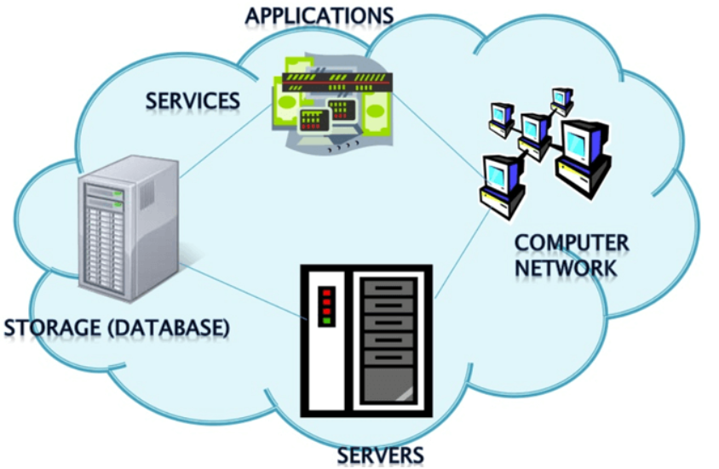

**Cost Savings:** Cost-saving is one of the biggest Cloud Computing benefits. It helps you to save substantial capital costs as it does not need any physical hardware investments. Also, you do not need trained personnel to maintain the hardware. The buying and managing of equipment are done by the cloud service provider.

**Strategic edge:** Cloud computing offers a competitive edge over your competitors. It is one of the best advantages of Cloud services that helps you to access the latest applications any time without spending your time and money on installations.

**High Speed:** Cloud computing allows you to deploy your service quickly in fewer clicks. This faster deployment allows you to get the resources required for your system within fewer minutes.

**Back-up and restore data:** Once the data is stored in a Cloud, it is easier to get the back-up and recovery of that, which is otherwise a very time taking process on-premise.

**Automatic Software Integration:** In the cloud, software integration is something that occurs automatically. Therefore, you don’t need to take additional efforts to customize and integrate your applications as per your preferences.

**Reliability:** Reliability is one of the biggest benefits of Cloud hosting. You can always get instantly updated about the changes.

**Mobility:** Employees who are working on the premises or at remote locations can easily access all the could services. All they need is Internet connectivity.

**Unlimited storage capacity:** The cloud offers almost limitless storage capacity. At any time you can quickly expand your storage capacity with very nominal monthly fees.

**Collaboration:** The cloud computing platform helps employees who are located in different geographies to collaborate in a highly convenient and secure manner.

**Quick Deployment:** Last but not least, cloud computing gives you the advantage of rapid deployment. So, when you decide to use the cloud, your entire system can be fully functional in very few minutes. Although, the amount of time taken depends on what kind of technologies are used in your business.

1. **Disadvantages of Cloud Computing**

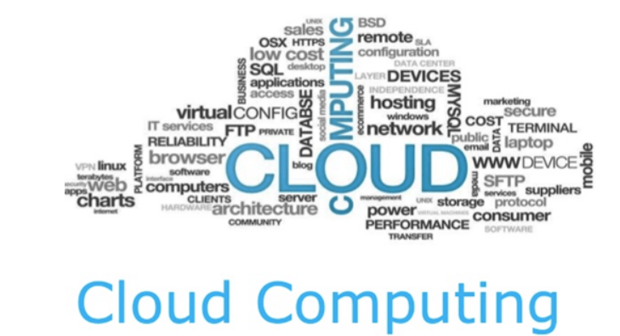

**Performance Can Vary:** When you are working in a cloud environment, your application is running on the server which simultaneously provides resources to other businesses. Any greedy behavior or DDOS attack on your tenant could affect the performance of your shared resource.

**Technical Issues:** Cloud technology is always prone to an outage and other technical issues. Even, the best cloud service provider companies may face this type of trouble despite maintaining high standards of maintenance.

**Security Threat in the Cloud:** Another drawback while working with cloud computing services is a security risk. Before adopting cloud technology, you should be well aware of the fact that you will be sharing all your company's sensitive information with a third-party cloud computing service provider. Hackers might access this information.

**Downtime:** Downtime should also be considered while working with cloud computing. That’s because your cloud provider may face power loss, low internet connectivity, service maintenance, etc.

**Internet Connectivity:** Good Internet connectivity is a must in cloud computing. You can't access the cloud without an internet connection. Moreover, you don't have any other way to gather data from the cloud.

**Lower Bandwidth:** Many cloud storage service providers limit the bandwidth usage of their users. So, in case if your organization surpasses the given allowance, the additional charges could be significantly costly

**Lacks of Support:** Cloud Computing companies fail to provide proper support to the customers. Moreover, they want their user to depend on FAQs or online help, which can be a tedious job for non-technical persons.

**Conclusion:** Despite all the Cloud Computing advantages and disadvantages, we can’t deny the fact that Cloud Computing is the fastest-growing part of network-based computing. It offers a great advantage to customers of all sizes: simple users, developers, enterprises, and all types of organizations. So, this technology here to stay for a long time.

1. **The development of cloud computing today:**

Data management has already become a must in every industry. The use of smartphones and tablets has increased dramatically during the previous 20 years. All large and small businesses rely on data that requires low-cost, easy-to-access storage.

Despite the fact that it has only been under development for a short period. Cloud infrastructure, on the other hand, is highly popular nowadays. Perhaps many of the applications and high-tech software we use (smartphones, tablets, laptops) include cloud computing programs that we aren’t aware of. The most common cloud infrastructure solutions we see now are:

iCloud of iPhone

Google Driver

1. **There are several reasons why the cloud becomes the new popular IT trend:**

Reduced costs: Cloud computing can reduce both capital costs (CAPEX) and operating costs (OPEX), as resources are purchased only when needed and only paid for when used.

Streamlined employee usage: Using the cloud unleashes valuable staff allowing them to focus on delivering value rather than maintaining hardware and software.

Flexible scalability: Cloud computing allows the ability to instantly scale, or increase or decrease at any time without the need for a long-term commitment.

1. **Cloud ecosystem:**

The cloud ecosystem is a dynamic web of interconnected components that work together to provide cloud services. Infrastructure-as-a-service (IaaS), platform-as-a-service (PaaS), and software-as-a-service (SaaS) are the three main categories of enterprise cloud computing (SaaS). (Blokland, 2013)

Common examples of SaaS, PaaS, & IaaS

|  |  |
| --- | --- |
| **Platform Type** | **Common Examples** |
| SaaS | Google Workspace, Dropbox, Salesforce, Cisco WebEx, Concur, GoToMeeting |
| PaaS | AWS Elastic Beanstalk, Windows Azure, Heroku, Force.com, Google App Engine, Apache Stratos, OpenShift |
| IaaS | DigitalOcean, Linode, Rackspace, Amazon Web Services (AWS), Cisco Metapod, Microsoft Azure, Google Compute Engine (GCE) |

**SaaS vs PaaS vs IaaS**

Each cloud model offers specific features and functionalities, and it is crucial for your organization to understand the differences. Whether you need cloud-based software for storage options, a smooth platform that allows you to create customized applications or complete control over your entire infrastructure without having to physically maintain it, there is a cloud service for you. (Blokland, 2013)

1. **SaaS: Software as a Service**

Software as a Service, also known as cloud application services, represents the most commonly utilized option for businesses in the cloud market. SaaS utilizes the internet to deliver applications, which are managed by a third-party vendor, to its users. A majority of SaaS applications run directly through your web browser, which means they do not require any downloads or installations on the client-side. (Blokland, 2013)

**SaaS Delivery**

Due to its web delivery model, SaaS eliminates the need to have IT staff download and install applications on each individual computer. With SaaS, vendors manage all potential technical issues, such as data, middleware, servers, and storage, resulting in streamlined maintenance and support for the business. (Blokland, 2013)

**SaaS Advantages**

* SaaS provides numerous advantages to employees and companies by greatly reducing the time and money spent on tedious tasks such as installing, managing, and upgrading software. This frees up plenty of time for technical staff to spend on more pressing matters and issues within the organization.

**SaaS Disadvantages:**

* This delivery model is that IT has little or no control.
* SaaS systems can not be paired with the other business apps or utilities used.

**SaaS Characteristics**

* Managed from a central location
* Hosted on a remote server
* Accessible over the internet
* Users not responsible for hardware or software updates

**When to Use SaaS**

* Startups or small companies that need to launch e-commerce quickly and don’t have time for server issues or software
* Short-term projects that require quick, easy, and affordable collaboration
* Applications that aren’t needed too often, such as tax software
* Applications that need both web and mobile access

**Some Example:**

Rackspace, Amazon Web Services

1. **PaaS: Platform as a Service**

Cloud platform services, also known as Platform as a Service (PaaS), provide cloud components to certain software while being used mainly for applications. PaaS delivers a framework for developers that they can build upon and use to create customized applications. All servers, storage, and networking can be managed by the enterprise or a third-party provider while the developers can maintain management of the applications. (Blokland, 2013)

**PaaS Delivery**

The delivery model of PaaS is similar to SaaS, except instead of delivering the software over the internet, PaaS provides a platform for software creation. This platform is delivered via the web, giving developers the freedom to concentrate on building the software without having to worry about operating systems, software updates, storage, or infrastructure. (Blokland, 2013)

PaaS allows businesses to design and create applications that are built into the PaaS with special software components. These applications, sometimes called middleware, are scalable and highly available as they take on certain cloud characteristics. (Blokland, 2013)

**PaaS Advantages**

No matter the size of your company, using PaaS offers numerous advantages, including:

* Simple, cost-effective development and deployment of apps
* Scalable
* Highly available
* Developers can customize apps without the headache of maintaining the software
* Significant reduction in the amount of coding needed
* Automation of business policy
* Easy migration to the hybrid model

**PaaS Disadvantages:**

* On the downside, PaaS, like IaaS, can result in unexpected costs, particularly as a scale of the application.
* This provides less versatility.

**PaaS Characteristics**

PaaS has many characteristics that define it as a cloud service, including:

* Builds on virtualization technology, so resources can easily be scaled up or down as your business changes
* Provides a variety of services to assist with the development, testing, and deployment of apps
* Accessible to numerous users via the same development application
* Integrates web services and databases

**When to Use PaaS**

Utilizing PaaS is beneficial, sometimes even necessary, in several situations. For example, PaaS can streamline workflows when multiple developers are working on the same development project. If other vendors must be included, PaaS can provide great speed and flexibility to the entire process. PaaS is particularly beneficial if you need to create customized applications. (Blokland, 2013)

This cloud service also can greatly reduce costs and it can simplify some challenges that come up if you are rapidly developing or deploying an app.

**Some Example:**

Windows Azure, Heroku, Force.com.

1. **IaaS: Infrastructure as a Service**

Cloud infrastructure services, known as Infrastructure as a Service (IaaS), are made of highly scalable and automated compute resources. IaaS is fully self-service for accessing and monitoring computers, networking, storage, and other services. IaaS allows businesses to purchase resources on-demand and as-needed instead of having to buy the hardware outright. (Blokland, 2013)

**IaaS Delivery**

IaaS delivers cloud computing infrastructure, including servers, network, operating systems, and storage, through virtualization technology. These cloud servers are typically provided to the organization through a dashboard or an API, giving IaaS clients complete control over the entire infrastructure. IaaS provides the same technologies and capabilities as a traditional data center without having to physically maintain or manage all of it. IaaS clients can still access their servers and storage directly, but it is all outsourced through a “virtual data center” in the cloud. (Blokland, 2013)

As opposed to SaaS or PaaS, IaaS clients are responsible for managing aspects such as applications, runtime, OSes, middleware, and data. However, providers of the IaaS manage the servers, hard drives, networking, virtualization, and storage. Some providers even offer more services beyond the virtualization layer, such as databases or message queues. (Blokland, 2013)

**IaaS Advantages**

IaaS offers many advantages, including:

* The most flexible cloud computing model
* Easy to automate the deployment of storage, networking, servers, and processing power
* Hardware purchases can be based on consumption
* Clients retain complete control of their infrastructure
* Resources can be purchased as-needed
* Highly scalable

**IaaS Disadvantages:**

* While the simplicity of scaling that makes the cloud appealing can often contribute to higher-than-expected bills-not to mention that consumers often loop models around and fail to switch them off, which can often increase the overall cost.
* Requires skilled staff

**IaaS Characteristics**

Characteristics that define IaaS include:

* Resources are available as a service
* Cost varies depending on consumption
* Services are highly scalable
* Multiple users on a single piece of hardware
* Organization retain complete control of the infrastructure
* Dynamic and flexible

**When to Use IaaS**

Just as with SaaS and PaaS, there are specific situations when IaaS is most advantageous.

* Startups and small companies may prefer IaaS to avoid spending time and money on purchasing and creating hardware and software.
* Larger companies may prefer to retain complete control over their applications and infrastructure, but they want to purchase only what they actually consume or need.
* Companies experiencing rapid growth like the scalability of IaaS and can change out specific hardware and software easily as their needs evolve.

**Some examples:**

Google Apps, Dropbox, Salesforce, Cisco WebEx.

While the specific advantages vary depending on the cloud services used, using a cloud service often implies that organizations do not have to purchase or maintain their own data systems:

* ATN firms with experience operating and managing these services are more likely to have a better experience and more trained people than a small company might be able to hire, allowing cloud suppliers to provide consumers with a more secure and efficient network.
* Leaving a high-usage application in the cloud, such as an app that is only used at certain times of the week or year, could be a cost-effective option for ATN companies rather than investing in specialized hardware and software.
* For ATN company, the only thing a user’s computer needs to be able to run the software is an interface to use the cloud computing system, which can be simply a Web browser, and the cloud network will take over the rest.
* No longer hire a computer, update programs or operating systems, or shut down and maintain hardware or devices, since it is on the vendor’s side.
* Instead of using an e-mail program on your computer, we’ll use the internet to access an e-mail account. Our account’s software and storage are hosted on the server's cloud computing.
* One advantage of using cloud storage solutions is that businesses can avoid the upfront costs and difficulties of purchasing and maintaining their own IT networks by paying just for what they need when they need it.

1. **Characteristic of the cloud:**

**On-demand self-service:** A consumer can unilaterally provision computing capabilities, such as server time and network storage, as needed automatically without requiring human interaction with each service provider. (Furht, 2010)

**Broad network access:** Capabilities are available over the network and accessed through standard mechanisms that promote use by heterogeneous thin or thick client platforms (e.g., mobile phones, tablets, laptops, and workstations).

**Resource pooling:** The provider’s computing resources are pooled to serve multiple consumers using a multi-tenant model, with different physical and virtual resources dynamically assigned and reassigned according to consumer demand. There is a sense of location independence in that the customer generally has no control or knowledge over the exact location of the provided resources but may be able to specify location at a higher level of abstraction (e.g., country, state ordatacenter). Examples of resources include storage, processing, memory and network bandwidth.

**Rapid elasticity:** Capabilities can be elastically provisioned and released, in some cases automatically, to scale rapidly outward and inward commensurate with demand. To the consumer, the capabilities available for provisioning often appear to be unlimited and can be appropriated in any quantity at any time.

**Measured service:** Cloud systems automatically control and optimize resource use by leveraging a metering capability at some level of abstraction appropriate to the type of service (e.g., storage, processing, bandwidth, and active user accounts). Resource usage can be monitored, controlled, and reported, providing transparency for the provider and consumer.

1. **Virtualization in cloud computing**

Virtualization is a technique of how to separate a service from the underlying physical delivery of that service. It is the process of creating a virtual version of something like computer hardware. It was initially developed during the mainframe era. It involves using specialized software to create a virtual or software-created version of a computing resource rather than the actual version of the same resource. With the help of Virtualization, multiple operating systems and applications can run on the same machine and the same hardware at the same time, increasing the utilization and flexibility of hardware. (Xing, 2012)

In other words, one of the main cost-effective, hardware reducing, and energy saving techniques used by cloud providers is virtualization. Virtualization allows sharing a single physical instance of a resource or an application among multiple customers and organizations at one time. It does this by assigning a logical name to physical storage and providing a pointer to that physical resource on demand. The term virtualization is often synonymous with hardware virtualization, which plays a fundamental role in efficiently delivering Infrastructure-as-a-Service (IaaS) solutions for cloud computing. Moreover, virtualization technologies provide a virtual environment for not only executing applications but also for storage, memory, and networking. (Xing, 2012)

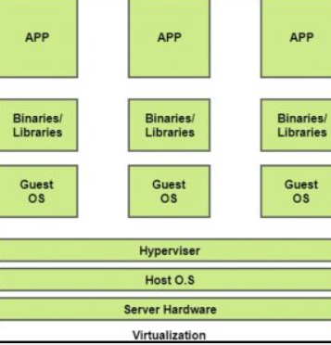

The machine on which the virtual machine is going to be build is known as Host Machine and that virtual machine is referred as a Guest Machine.

1. **Multicore in cloud computing**

Multicore refers to an architecture in which a single physical processor incorporates the core logic of more than one processor. A single integrated circuit is used to package or hold these processors. These single integrated circuits are known as die. Multicore architecture places multiple processor cores and bundles them as a single physical processor. The objective is to create a system that can complete more tasks at the same time, thereby gaining better overall system performance. (Wang, 2010)

This technology is most commonly used in multicore processors, where two or more processor chips or cores run concurrently as a single system. Multicore-based processors are used in mobile devices, desktops, workstations, and servers. (Wang, 2010)

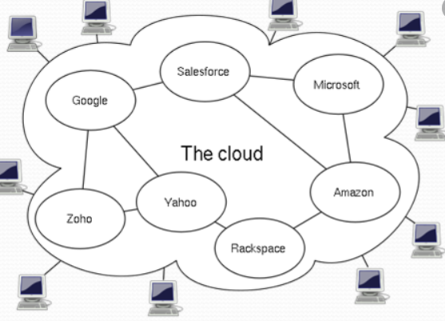

1. **Persuade the ATN from adopting cloud computing.**

ATN has several toy shops across Vietnam. Management also takes a long time to collect income from outlets, preventing the board from seeing stock specifics. As a result, ATN firms must use the Cloud Computing program. Since cloud computing is a relatively new concept, it is rapidly gaining popularity. In fact, the most significant benefit of cloud computing is cost reduction. It is simple to use for business administrators, and they may access it at any time and from anywhere using only the Internet. Quick is independent of the software or hardware used. Unless all data has been backed up to another hard drive, if the administrative hard disk fails, all data could be lost. Meanwhile, your data will be safer if it is stored in a Cloud Computing application. Service providers look after corporate data and administrative data (Backed up periodically). If the hard disk fails, the carrier will replace it, and your data will be protected. Of course, there are no absolutes. However, the chances of losing data are substantially lower.

Managers may control all of the branch store data utilizing cloud computing from anywhere as long as they have an internet connection. Another benefit of cloud computing is its flexibility and mobility. The corporate chain may operate at any time, resulting in fewer corporate workstations. Furthermore, cloud computing enables business leaders to keep a close eye on their operations.

# **Design an appropriate architectural Cloud Computing framework for a given scenario.**

ATN is a toy company with branches in many other locations and in trouble managing the sales of the stores.

The site side should be put on the cloud to guarantee the maintenance and sales control of each shop so that users can manage all stores in various regions. Yet there are two important users here are staff and management:

Employees have the ability to manage items and product types. Management will be able to manage staff by providing distinct login credentials to each salesperson in different sales zones. Managers can manage employees anywhere at any time, just equipment with a network connection.

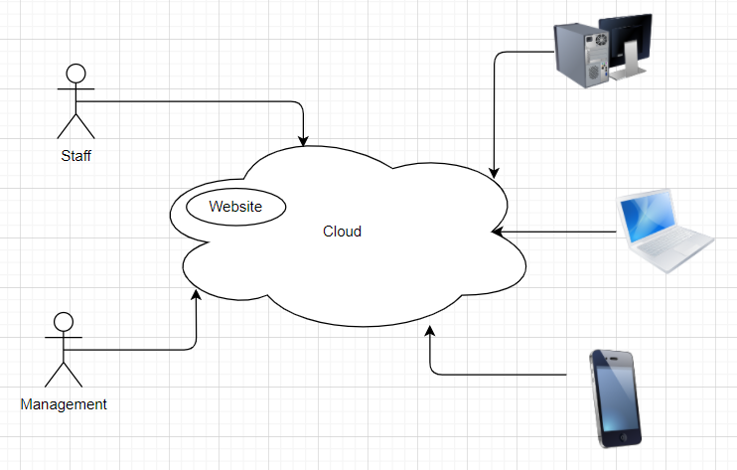

## **Use Case Diagram**

Provide a Use Case diagram, which describes the requirements that the system must fulfill:

Employees who wish to look at products do not need to log in, but they must log in using the staff's account while collecting sales.

For Administrators, when logged in, they can add, edit, and delete products, categories.

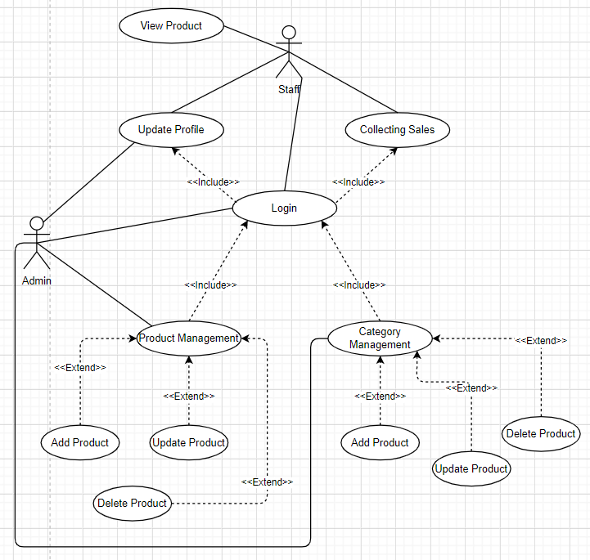

## **Site map**

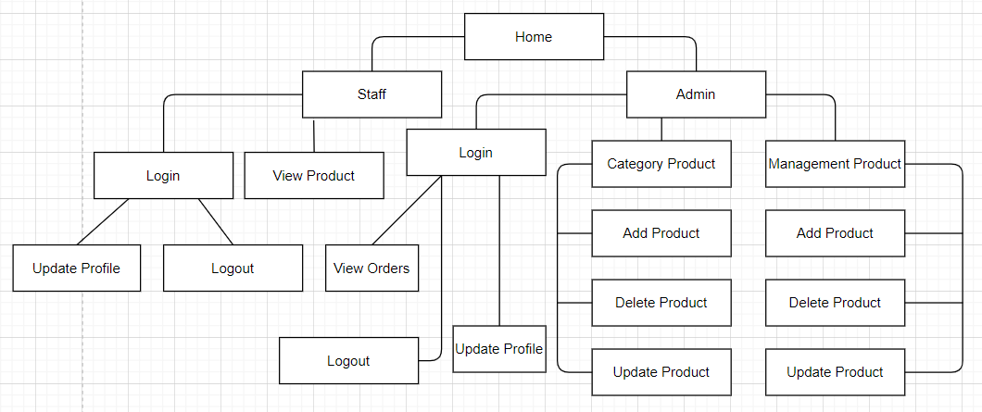

# **Define an appropriate deployment model for a given scenario.**

## **Cloud Computing Model**

Cloud resources in a number of forms may be coordinated or delivered. The method of delivery is based on the client company’s criteria. The deployment model specifies cloud utilization and also sets the access cap. The NIST definition refers to public, private, and hybrid deployments to four different delivery types. Both clouds come into one of these four groups.

The NIST concept refers to four the models of deployment as public, private, group and hybrid deployments:

## **Deployment Model**

For the current situation of ATN company, we recommend using the public cloud. Below are some reasons for this recommendation:

Firstly, the price is reasonable. ATN has a middling revenue despite being a major firm. As a result, cost-cutting is critical. The majority of public cloud providers allow enterprises to bill on an hourly basis. It allows firms to keep expenses under strict control by only paying for the infrastructure that they require. Furthermore, with the public cloud, ATN only needs to spend money on cloud services rather than on IT engineers to operate, maintain, and repair the system, such as servers, hardware, and software, allowing the company to restructure its IT team and focus resources on areas that generate more revenue.

Secondly, it’s simple to get started with the public cloud. ATN can build up their public cloud in a matter of hours. It can be purchased quickly over the Internet and remotely deployed and configured via the cloud provider’s website.

Thirdly, the hardware, software, and network in the cloud will be maintained by the public cloud provider. As a result, the ATN organization does not have to worry about infrastructure updates, security issues, or upgrades, resulting in significant cost savings.

Especially the large scalability and flexibility: Because ATN wants to grow larger and manage on the same system as rapidly and easily as feasible, this is a critical feature. However, the level of security is minimal, yet it is sufficient to safeguard ATN’s information security.

## **Public clouds**

A public cloud is a type of computing in which a service provider makes resources available to the public via the internet. Resources vary by provider but may include storage capabilities, applications, or virtual machines. The public cloud allows for scalability and resource sharing that would not otherwise be possible for a single organization to achieve. (Furht, 2010)

Some public cloud providers offer resources for free, while clients pay for other resources by subscription or a pay-per-usage model. Cloud services are available to individual users, as well, and prices scale depending on the user's resource needs. Organizations with huge amounts of data need to develop a cloud migration strategy before choosing a cloud vendor.

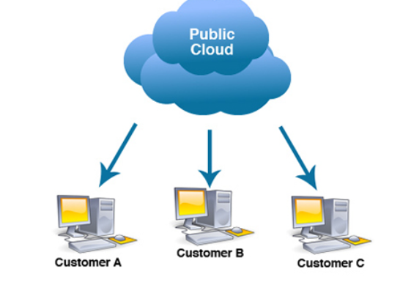

**Benefits of Public Cloud**

It eliminates organizations' need to invest in and manage their own IT capital at the premises;

It enables scalability to meet workload and user demands

There are fewer wasted resources because customers only pay for what they use consumers pay only for what they are using.

**Public Cloud architecture**

A public cloud is a completely virtualized system. Providers also offer a multi-tenant model, which allows users or tenants to share computing resources. In the public cloud, however, each tenant's data is kept separate from that of other renters. To move data quickly, the public cloud relies on high-bandwidth network connectivity.

The majority of public cloud storage is redundant, with many data centers and diligent file version replication. This function has earned it a reputation as a dependable feature.

Public cloud architecture can be further categorized by service model. Common service models include:

Software as a service (SaaS), in which a third-party provider hosts applications and makes them available to customers over the internet.

Platform as a service (PaaS), in which a third-party provider delivers hardware and software tools, usually those needed for application development, to its users as a service;

Infrastructure as a service (IaaS), in which a third-party provider offers virtualized computing resources, such as VMs and storage, over the internet or through dedicated connections.

## **Private cloud**

The private cloud is defined as computing services offered either over the Internet or a private internal network and only to select users instead of the general public. Also called an internal or corporate cloud, private cloud computing gives businesses many of the benefits of a public cloud - including self-service, scalability, and elasticity - with the additional control and customization available from dedicated resources over a computing infrastructure hosted on-premises. In addition, private clouds deliver a higher level of security and privacy through both company firewalls and internal hosting to ensure operations and sensitive data are not accessible to third-party providers. One drawback is that the company’s IT department is held responsible for the cost and accountability of managing the private cloud. So private clouds require the same staffing, management, and maintenance expenses as traditional data center ownership. (Furht, 2010)

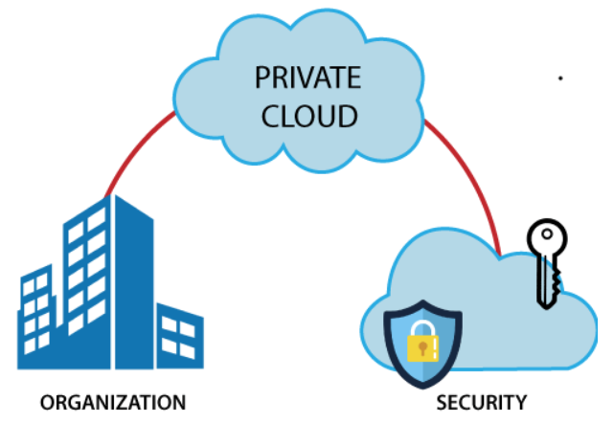

**Benefits of Private Cloud**

Cost and resource efficiency: Private cloud services resources are not as cost-effective as public cloud resources, but they are more efficient.

More Control: Private Cloud gives users more control over its resources and hardware than Public Cloud because it is only accessible on 1 organization.

High security and privacy: neither the operations on this private virtual server nor the shared resources from entirely distinct resource clusters are publicly accessible. As a result, private cloud systems frequently provide great levels of privacy and security.

* + - 1. **Community cloud**

A community cloud is a cloud service model that provides a cloud computing solution to a limited number of individuals or organizations that is governed, managed, and secured commonly by all the participating organizations or a third-party managed service provider. (Furht, 2010)

**Benefits of Community Cloud**

Cost reduction

Improved security, privacy, and reliability

Ease of data sharing and collaboration

## **Hybrid clouds**

A hybrid cloud—sometimes called a cloud hybrid—is a computing environment that combines an on-premises datacenter (also called a private cloud) with a public cloud, allowing data and applications to be shared between them. Some people define hybrid cloud to include “multicloud” configurations where an organization uses more than one public cloud in addition to their on-premises datacenter. (Furht, 2010)

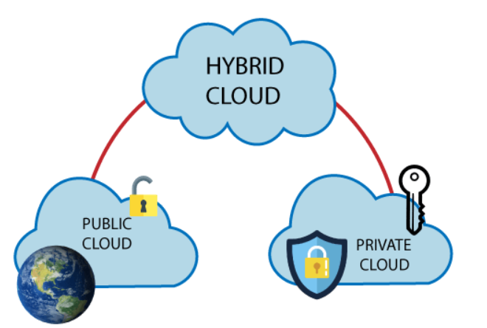

**Benefits of Hybrid Cloud**

Improved security and privacy

Enhanced scalability and flexibility

Reasonable price

## **The comparative analysis of the best deployment models**

|  |  |  |  |
| --- | --- | --- | --- |
|  | **Public clouds** | **Private cloud** | **Hybrid clouds** |
| **Ease of setup and use** | Easy | Requires IT proficiency | Requires IT proficiency |
| **Data security and privacy** | Low | High | High |
| **Data control** | Little to none | High | Comparatively high |
| **Reliability** | Vulnerable | High | High |
| **Scalability and flexibility** | High | High | High |
| **Cost-effectiveness** | The cheapest one | Cost-intensive, the most expensive one | Cheaper than a private model but more costly than a public one |
| **Demand for in-house hardware** | No | Depends | Depends |

# **Compare the service models for choosing an adequate model for a given scenario.**

* + - 1. **Service model should be used**

Platform-as-a-Service (PaaS) would be the right choice for the ATN company.

**Serverless computing**

Overlapping with PaaS, serverless computing focuses on developing the features of the device without wasting time maintaining the servers and resources necessary to do so continuously. The cloud service manages you with configuration, application preparation, and storage management. Serverless systems are highly flexible and event-based, utilizing only resources when there is a particular task or cause. (Furht, 2010)

* 1. **Because**

First, PaaS will provide the whole cycle with a fast pace and versatility, it is ideally equipped for corporate data collection. As a result, this online infrastructure can drastically save costs by removing any complications that arise as a user rapidly develops and introduces a program.

Second, PaaS needs less time and management skills, resulting in a lower TCO. As a result, this cloud service can help you save money while also addressing some of the challenges that arise when building or delivering a system quickly.

Lastly, Authentication and data protection measures, as well as redundancy techniques such as replication and backup, are typically implemented into PaaS solutions. This would strengthen security and increase the requirement for internal security expertise. PaaS systems can be used to construct applications that are then sold as a software kit as a service (SaaS) to other users and customers for specific reasons, making PaaS very beneficial for the business.

* + - 1. **Programming language NodeJS should be used**

**3.1. What is Node.js?**

Node.js is a server-side platform built on Google Chrome's JavaScript Engine (V8 Engine). Node.js was developed by Ryan Dahl in 2009 and its latest version is v0.10.36. The definition of Node.js as supplied by its official documentation:

Node.js is a platform built on Chrome’s JavaScript runtime for easily building fast and scalable network applications. Node.js uses an event-driven, non-blocking I/O model that makes it lightweight and efficient, perfect for data-intensive real-time applications that run across distributed devices. (Teixeira, 2012)

Node.js is an open-source, cross-platform runtime environment for developing server-side and networking applications. Node.js applications are written in JavaScript, and can be run within the Node.js runtime on OS X, Microsoft Windows, and Linux.

Node.js also provides a rich library of various JavaScript modules which simplifies the development of web applications using Node.js to a great extent.



**3.2. Features of Node.js**

Asynchronous and Event Driven − All APIs of the Node.js library are asynchronous, that is, non-blocking. It essentially means a Node.js based server never waits for an API to return data. The server moves to the next API after calling it and a notification mechanism of Events of Node.js helps the server to get a response from the previous API call.

Very Fast − Being built on Google Chrome's V8 JavaScript Engine, the Node.js library is very fast in code execution.

Single-Threaded but Highly Scalable − Node.js uses a single-threaded model with event looping. The event mechanism helps the server to respond in a non-blocking way and makes the server highly scalable as opposed to traditional servers which create limited threads to handle requests. Node.js uses a single-threaded program and the same program can provide service to a much larger number of requests than traditional servers like Apache HTTP Server.

No Buffering − Node.js applications never buffer any data. These applications simply output the data in chunks.

License − Node.js is released under the MIT license.

**3.3. Advantages of Node.js**

Node.js offers numerous benefits for web app development such as high scalability, ease of learning, extraordinary performance, profound extensiveness, active support from a large community of developers, among others.

**3.4. Disadvantages of Node.js**

Node.js has some cons like unstable Application Programming Interface (API), lack of a robust library support system, and lack of experienced Node.js developers in the market.

**3.5. Benefits of using Node.js**

Chrome’s V8 engine, the fastest javascript engine, significantly improves Node.js performance. Node.js is single-threaded. asynchronous, and works on a non-blocking I/O model. This boosts performance by handling multiple concurrent threads simultaneously with fewer resources.

* + - 1. **The database should be used is MongoDB**

**4.1. What is MongoDB?**

MongoDB is a document-oriented NoSQL database used for high-volume data storage. Instead of using tables and rows as in the traditional relational databases, MongoDB makes use of collections and documents. Documents consist of key-value pairs which are the basic unit of data in MongoDB. Collections contain sets of documents and functions which is the equivalent of relational database tables. MongoDB is a database that came to light around the mid-2000s. (Chodorow, 2013)

**4.2. MongoDB Features**

Each database contains collections which in turn contains documents. Each document can be different with a varying number of fields. The size and content of each document can be different from each other.

The document structure is more in line with how developers construct their classes and objects in their respective programming languages. Developers will often say that their classes are not rows and columns but have a clear structure with key-value pairs.

The rows (or documents as called in MongoDB) don't need to have a schema defined beforehand. Instead, the fields can be created on the fly.

The data model available within MongoDB allows you to represent hierarchical relationships, store arrays, and other more complex structures more easily.

Scalability – MongoDB environments are very scalable. Companies across the world have defined clusters with some of them running 100+ nodes with millions of documents within the database

**4.3. Advantages Of MongoDB**

**4.3.1. Flexible Database**

We know that MongoDB is a schema-less database. That means we can have any type of data in a separate document. This thing gives us flexibility and the freedom to store data of different types.

**4.3.2. Sharding**

We can store a large data by distributing it to several servers connected to the application. If a server cannot handle such big data then there will be no failure condition. The term we can use here is “auto-sharding”.

**4.3.3. High Speed**

MongoDB is a document-oriented database. It is easy to access documents by indexing. Hence, it provides a fast query response. The speed of MongoDB is 100 times faster than the relational database.

**4.3.4. High Availability**

MongoDB has features like replication and gridFS. These features help to increase data availability in MongoDB. Hence the performance is very high.

**4.3.5. Scalability**

A great advantage of MongoDB is that it is a horizontally scalable database. When you have to handle large data, you can distribute it to several machines.

**4.3.6. Ad-hoc Query Support**

MongoDB has a very advanced feature for ad hoc queries. This is why we don’t need to worry about fore-coming queries coming in the future.

**4.3.7. Easy Environment Setup**

It is easier to set up MongoDB than RDBMS. It also provides a JavaScript client for queries.

**4.3.6. Full Technical Support**

MongoDB Inc. provides professional support to its clients. If there is any problem, you can directly reach the MongoDB client support system.

**4.4. Disadvantages Of MongoDB**

**4.4.1. Joins not Supported**

MongoDB doesn’t support joins like a relational database. Yet one can use joins functionality by adding by coding it manually. But it may slow execution and affect performance.

**4.4.2. High Memory Usage**

MongoDB stores key names for each value pairs. Also, due to no functionality of joins, there is data redundancy. This results in increasing unnecessary usage of memory.

**4.4.3. Limited Data Size**

You can have document size, not more than 16MB.

**4.4.4. Limited Nesting**

You cannot perform nesting of documents for more than 100 levels.

This was all about Advantages Of MongoDB Tutorial. Hope you like our explanation.

* + - 1. **Cloud platform should be used is Heroku**

**5.1. What is Heroku?**

Heroku is a container-based cloud Platform as a Service (PaaS). Developers use Heroku to deploy, manage, and scale modern apps. Our platform is elegant, flexible, and easy to use, offering developers the simplest path to getting their apps to market. (Hanjura, 2014)

Heroku is fully managed, giving developers the freedom to focus on their core product without the distraction of maintaining servers, hardware, or infrastructure. The Heroku experience provides services, tools, workflows, and polyglot support_all designed to enhance developer productivity. (Hanjura, 2014)

Heroku is a widely relied-upon platform as a service offering that enables developers to carry out hassle-free application deployment, scaling, and management. This platform offers support for a wide range of programming languages such as Java, Ruby, PHP, Node.js, Python, Scala, and Clojure. Heroku runs applications through virtual containers known as Dynos. (Hanjura, 2014)

**5.2. Advantages Heroku**

**5.2.1. Free to Start**

Users can get started with the free tier of Heroku, which does come with some restrictions and fundamental functionality. It is a suitable plan for those who intend to create a basic cloud app. Developers can opt for this plan initially before committing to the platform. You can use it for testing the features of Heroku and figuring out if it’s a suitable fit for your application needs.

**5.2.2. Easy to Use**

As a leading platform as a service offering, Heroku is known for its ease-of-use. The free version of Heroku is best suited for small development projects. Developers can also opt for several different tier packages that are more suitable for large businesses’ complicated requirements. The intuitive Heroku platform dashboard helps users perform easy scaling, management, and application monitoring.

**5.2.3. Developer-Centric**

Heroku focuses on helping developers hone their skills to create feature-rich applications. The experience is favorable for developers as they access some useful tools to accelerate core development processes. They are free from having to perform various repetitive tasks and can concentrate on critical development actions. Heroku’s vast array of features can breathe life into any application development project.

**5.2.4. Let developers concentrate on coding and not server management**

Heroku takes away the burden of server management and gives developers access to an easy-to-use web UI. One-click deployments are also quite convenient for developers once an application is running. They can create new software releases conveniently in the form of release branches and quickly deploy branches across different environments. The ease of running Heroku makes it a convenient choice for application development.

**5.2.5. Easy to scale**

Heroku PaaS relies on a Dyno for running the code written by developers. Each dyno is fundamentally a container encapsulating resources such as memory and CPU and application code and related dependencies.

Heroku users can then choose to create any number of independent application copies once it has been prepared, a process known as horizontal scaling. Applications that receive an unprecedented influx of traffic can be handled through the one-click creation of hundreds of app instances.

Heroku’s auto-scaling feature helps it easily detect traffic spikes and create more Dynos accordingly.

**2.2.6. Security**

Heroku offers developers a secure way of developing applications due to its set of security features. This PaaS platform reduces developers’ requirement to push constant security patches, which can be a hassle, especially in more sophisticated web applications. Heroku ensures an optimal level of security for servers, application code and prevents any possible issues.

**5.2.7. Powerful CLI**

Heroku Command Line Interface or CLI is a feature that helps to develop and manage Heroku applications conveniently. The CLI is, in fact, one of the most reliable components of the Heroku PaaS.

**5.2.8. Great Plugins & Third Party Support**

The Heroku ecosystem consists of many cloud services that can prove to be quite essential for developers’ needs. These are quite useful for creating, managing, and operating applications.

Integrated Add-ons make it effortless for developers to perform service installations and manage configurations, billing, and data from CLI or Heroku Dashboard. Heroku also offers several add-ons that facilitate greater functionality by integrating platform API, processes, and logs. Some of the add-ons include Bucketeer, Redis To Go, Cloudcube, and more.

**5.2.9. It’s part of Salesforce**

The Heroku PaaS is a part of SalesForce, one of the most reliable software industry names. Since its acquisition by SalesForce, Heroku has also been developed considerably and achieved many more integrations. The companies are working together to provide high-quality solutions to meet the needs of businesses around the world.

Developers can build apps on Heroku and utilize Heroku Connect for data syncing between Heroku’s Postgres and deployment of SalesForce. The partnership of Heroku and SalesForce has created a PaaS product that enables swift and hassle-free development on high-quality applications.

**5.2.10. Enterprise Support**

Heroku Enterprise comes with several Pro Module options that help developers get the best out of their applications. The company lays a strong focus on assisting enterprises to simplify their application development processes. The 3 Modules offered for enterprises are App Assessment, Plan for Application Scaling, and Solution Proposal.

**5.3. Disadvantages Heroku**

**5.3.1. Price**

Heroku is considered to be an expensive option by many developers compared to other platforms. Some scaling issues can influence your decision to opt for it. Resource utilization is not optimal, and costs can rise with Heroku. Notably, Heroku is more expensive compared to AWS and several other key competitors.

**5.3.2. Sleeping Apps**

A single web dyno assigned to a Heroku application goes into sleep when it has not received traffic for an hour. The dyno wakes up automatically for processing when the application is reaccessed. Sleeping applications can be a potential issue for some businesses. However, applications that have multiple dynos do not go to sleep.

**5.3.3. Limited Regions**

Heroku is only available for the US and Europe regions, although it runs over the AWS platform. While it might be suitable for any business based in these two regions of having customer bases within them. But, if you are a business with an application with Asian country customers, there can be some lead time issues. This is one of the limitations that makes potential users outside Europe and the USA look at Heroku alternatives.

**5.3.4. Less Flexibility vs a IaaS**

Heroku is a platform as a service offering, and the level of flexibility it offers is low compared to an IaaS service provider. Despite providing a vast array of features and add-ons, the platform is still limited in development types. IaaS is a model that offers peak flexibility for custom application development use cases, and a PaaS like Heroku is generally built atop an IaaS.

**5.3.5. Limited Types of Instances**

The Heroku PaaS is also limited in terms of the instance types it offers to users. Currently, developers can choose from just six different Dyno types, which all come with a specific memory, computing, CPU share limits, and dedicated server variations.

Several of these plans do not feature dedicated servers, and the memory and CPU limitations are worth looking over. Alternatively, services such as AWS offer a lot more variety in terms of instance types to users. Businesses or users with limited requirements can use Heroku without hassle, but growing scalability demands can be motivation enough to opt for an alternative.

**5.3.6. Does not provide static IP addresses**

A static IP address is a fundamental requirement for most businesses, and having one can prove to be quite an advantage. By default, Heroku does not offer static IP addresses within CRE (Common Runtime Environment).

Users have to opt for the expressive Heroku Private Spaces to get static IP addresses that are not optimal regarding load balancing or customization. Users have to rely on third-party static IP add-on providers to use this IP type with Heroku. The complexity of utilizing this feature can be a concern for developers and business owners alike and can influence them to go for other providers.

**5.3.7. Does only charge in USD and no local currency support**

Heroku only charges its customers in USD and not in other currencies, including Euro. This can be a minor inconvenience for business owners that prefer to pay in their currencies.

1. **GitHub**

GitHub is a code hosting platform for version control and collaboration. It lets you and others work together on projects from anywhere. (Blischak, 2016)

This tutorial teaches you GitHub essentials like repositories, branches, commits, and Pull Requests. You’ll create your own Hello World repository and learn GitHub’s Pull Request workflow, a popular way to create and review code. (Blischak, 2016)

* 1. **What are GitHub’s Features**

**6.1.1. Easy Project Management**

GitHub is a place where project managers and developers come together to coordinate, track, and update their work so that projects are transparent and stay on schedule.

**6.1.2. Increased Safety With Packages**

Packages can be published privately, within the team, or publicly to the open-source community. The packages can be used or reused by downloading them from GitHub.

**6.1.3. Effective Team Management**

GitHub helps all the team members stay on the same page and organized. Moderation tools like Issue and Pull Request Locking help the team to focus on the code.

**6.1.4. Improved Code Writing**

Pull requests help the organizations to review, develop, and propose new code. Team members can discuss any implementations and proposals through these before changing the source code.

**6.1.5. Increased Code Safety**

GitHub uses dedicated tools to identify and analyze vulnerabilities to the code that other tools tend to miss. Development teams everywhere work together to secure the software supply chain, from start to finish.

**6.1.6. Easy Code Hosting**

All the code and documentation are in one place. There are millions of repositories on GitHub, and each repository has its own tools to help you host and release code.

1. **Explain the diagram**



Cloud-based service Requests are sent to a cloud service by customers.

The cloud service is automatically monitored to see whether the specified capacity threshold is surpassed.

If the workload does not surpass the power threshold throughout this process. The request will be routed to the cloud service as normal if the workload is less than or equal to the capacity threshold.

The amount of service requests from cloud service users is steadily growing. The workload has above the performance barrier. Based on a preset scaling strategy, the scaling listener automatically chooses the next course of action.

If enough resources, such as RAM, are available to scale the deployment, the auto-scaling mechanism will begin the sharing process. In response to the number of requests from users, the scale listener automatically sends a signal to the resource replication mechanism, which generates several instances of the cloud service.

Requests from users to the cloud service will be canceled if the storage capacity does not meet the size of deployment.

## **Conclusion**

Cloud computing is becoming more popular all around the world. There are a variety of cloud computing models, but the overarching purpose is to engage and progress every business plan with technology’s expanding capsabilities. It is feasible to reduce labor time and costs by employing Cloud computing. The advantages of cloud computing over traditional data management methods.

# **References**

Furht, B. and Escalante, A., 2010. *Handbook of cloud computing* (Vol. 3). New York: springer.

Blokland, K., Mengerink, J. and Pol, M., 2013. *Testing cloud services: how to test SaaS, PaaS & IaaS*. Rocky Nook, Inc.

Xing, Y. and Zhan, Y., 2012. Virtualization and cloud computing. In *Future Wireless Networks and Information Systems* (pp. 305-312). Springer, Berlin, Heidelberg.

Wang, L., Tao, J., von Laszewski, G. and Marten, H., 2010. Multicores in Cloud Computing: Research Challenges for Applications. *JCP*, *5*(6), pp.958-964.

Teixeira, P., 2012. *Professional Node. js: Building Javascript based scalable software*. John Wiley & Sons.

Chodorow, K., 2013. *MongoDB: the definitive guide: powerful and scalable data storage*. " O'Reilly Media, Inc.".

Hanjura, A., 2014. *Heroku Cloud Application Development*. Packt Publishing Ltd.

Blischak, J.D., Davenport, E.R. and Wilson, G., 2016. A quick introduction to version control with Git and GitHub. *PLoS computational biology*, *12*(1), p.e1004668.